SLCClogo-BrandColors2015.epsMS Word 2007

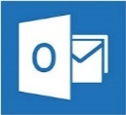

MS Outlook

Mailbox Maintenance

Introduction 1

Understanding the MS Outlook Mailbox 1

Basic Mailbox Maintenance 1

Mailbox Cleanup 1

Check Your Mailbox Size 1

The Quota Information Button 2

Auto Delete - Empty the Deleted Items Folder Automatically: 4

The Sent Items Folder 5

Manually Deleting Sent Items 5

Manually Removing Attachments from Items 6

Turn off the *Save Copies in Sent Items* feature 7

The Inbox Folder 7

Creating Subfolders 8

AutoArchive Basics 9

Find / Change AutoArchive Default Settings 9

Changing AutoArchive Settings for Individual Folders 12

Explanation of *(Folder Name) Properties* Dialog Box: 13

# Introduction

## Understanding the MS Outlook Mailbox

**Salt Lake Community College** (**SLCC**) uses the **Microsoft Exchange Server** system for **MS Outlook**. Each **SLCC** Outlook user is allocated:  
**368mb** of storage  
on the MS Exchange Server. This is the user’s **virtual Mailbox**. This **Mailbox** stores all **Outlook** folder contents, including ***Email***, ***Calendar***, ***Contacts***, etc. Based on an average email size of 40 kb, this allows storage of nearly 9,000 emails.

It is the responsibility of each user to maintain their **Mailbox** within the allocated storage limitations. Approaching or exceeding the allocated space results in:

|  |  |
| --- | --- |
| **Approaching 340** mb | User receives a **Warning** email from **Desktop Support** that Mailbox size must be reduced. |
| **Exceeding 360** mb | User will not be able to **Send** emails using **Outlook**. |
| **Exceeding 400** mb | User will not be able to **Send** or **Receive** emails using **Outlook**. |

# Basic Mailbox Maintenance

The following folders use most of a mailboxes storage space:

* Inbox
* Sent Items
* Deleted Items

If the mailbox is approaching 340 mb, focus on cleaning out these folders first. The ***Mailbox Cleanup Tool*** is a convenient utility to help manage mailbox size.

## Mailbox Cleanup

The 2013 version of **Outlook** provides several tools for mailbox maintenance.

### Check Your Mailbox Size

Determining how much space the **Mailbox** is using is the first step of Mailbox Maintenance. There are several tools that make this easy.

### The Quota Information Button

The Quota Information button is located on the left edge of the Status Bar. By default it is turned off. When turned on it will display the amount of free space in your mailbox. To turn it on, do the following:

|  |  |
| --- | --- |
| Turn on the **Quota Information** button:   1. Located on the bottom right corner of Outlook’s Status Bar. 2. Displays the amount of free space in your mailbox. 3. If not visible, right click on a blank area of the Status Bar and select Quota Information form the menu. | C:\Users\rhunt29\AppData\Local\Temp\1\SNAGHTML133822b.PNG |
| The ***Mailbox Cleanup*** section:   1. Found on the **File** tab, it contains a bar graph which graphically depicts your mailbox size. 2. Has the Cleanup Tools button | C:\Users\rhunt29\AppData\Local\Temp\1\SNAGHTML13c0c43.PNG |
| Clicking on the ***Cleanup Tools*** button displays its 3 cleanup options:   * Mailbox Cleanup… * Empty Deleted Items Folder * Archive…   Each of these options are discussed below. |  |

|  |  |
| --- | --- |
| Selecting ***Mailbox Cleanup*** opens the **Mailbox Cleanup** utility. Here you can:   1. View your mailbox size by folder. 2. Search for either large or old items. 3. Run **AutoArchive** one time. **Note:** Find more information in the **AutoArchive Basics** section, Page 10. 4. Empty the **Deleted Items** folder. 5. Delete alternate versions of items. |  |
| Selecting the ***Empty*** ***Deleted Items*** ***Folder*** button deletes the contents of that folder. **Note:** Learn about Outlook’s **Auto Delete** feature on the next page. |  |
| Selecting ***Archive…*** opens the **Archive** dialog box. This provides settings for running Archive one time.   1. Select to run Archive on all folders. 2. Select to choose a folder to Archive. 3. Select “age” of items to be archived. 4. Check to include Items marked **Do not AutoArchive**. 5. Accept the default Archive location or ***Browse*** to your own. 6. Click ***OK*** to run one time. | C:\Users\rhunt29\AppData\Local\Temp\1\SNAGHTML148810b.PNG |

### Auto Delete - Empty the Deleted Items Folder Automatically:

The **Auto Delete** feature of **Outlook** automatically empties the ***Deleted Items Folder*** each time Outlook is shut down. By default, this feature is not turned on.

To turn on **Auto Delete**:

|  |  |
| --- | --- |
| 1. Select the **File** tab on the Ribbon. 2. Click on ***Options***. 3. In the **Outlook Options** window, select ***Advanced***. 4. In the Outlook start and exit section, click on the Empty Deleted Items folder when exiting Outlook.   **Auto Delete** is now turned on. | C:\Users\rhunt29\AppData\Local\Temp\1\SNAGHTML1540077.PNG |
| With **Auto Delete** turned on, the deleted items folder will be emptied when Outlook is shut down.  Also, by default you will see an **alert message** asking if you really want to delete the Items.  Click ***Yes*** to proceed with deletion and shut down. |  |
| **Note:** If you don’t want to see the alert message do the following:  While on the ***Advanced*** button (**1**) page in the **Outlook Options** window, scroll down to the **Other** section (**2**).  Uncheck the **Prompt for confirmation…** checkbox (3).  Click ***OK*** to save your changes. |  |

## The Sent Items Folder

When you send an email, by default **Outlook** creates a copy of that email, including any attachments, and stores it in the ***Sent Items*** folder. If the ***Sent Items*** folder is using too much mailbox space, there are four options to manage its size:

* **Manually** delete entire items in the ***Sent Items*** folder.
* **Manually** remove the attachments from items.
* Turn off the Save Copies in Sent Items feature.
* **AutoArchive** the folder contents (See ***AutoArchive Instructions for Individual Folders*** on page 14.

### Manually Deleting Sent Items

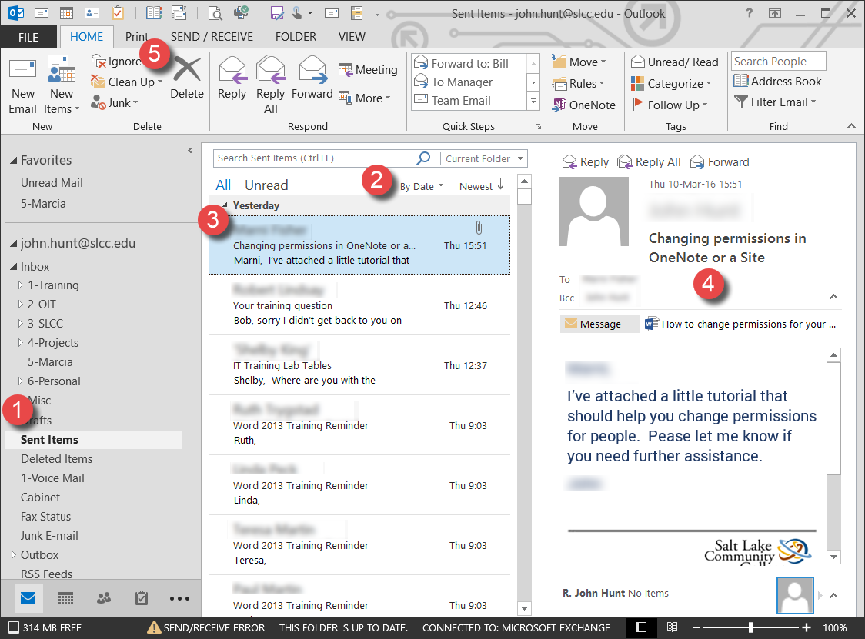

1. Under Mail Box – (Your Name) select the Sent Items folder.
2. Emails will be displayed in the middle **Folder Contents** pane.
3. Select an email in the ***Folder Contents*** pane to delete.  
   **Note:** To select more than one email, hold down the ***Ctrl*** key on the keyboard as you select emails.
4. This displays the email’s contents in the **Preview** pane on the right.
5. To delete a selected email, click the ***Delete*** button in the **Tool Bar**.

### Manually Removing Attachments from Items

Email attachments can quickly take up storage space in your Mailbox. It may be desirable to save emails in the ***Sent Items*** folder to have a record that they were sent. However, if a file has been attached, it may not be necessary to leave the file attached to the email.

To **remove an attachment** from an email:

|  |  |
| --- | --- |
| 1. Select the ***Sent Items*** folder and click on the email with the attachment in the Folder Contents pane.   **NOTE:** An email attachment is indicated by the **Paper Clip** icon.   1. In the preview pane, right click on the **email attachment**. 2. From the menu, select ***Remove Attachment***.   The attachment is removed from the email and deleted. | C:\Users\rhunt29\AppData\Local\Temp\1\SNAGHTML15a41039.PNG |

### Turn off the *Save Copies in Sent Items* feature

By default, **Outlook** creates a copy of every email you send, including any attachments, and stores it in the ***Sent Items*** folder. These emails and any attachments are taking up your mailbox space. This feature can be turned off by doing the following:

|  |  |
| --- | --- |
| 1. Select the **File** tab. 2. Select the ***Options*** button. 3. When the **Outlook Options** page opens, select the ***Mail*** button. 4. Scroll down to the **Save Messages** section. 5. Click the Save copies of messages in the Sent Items folder check box to remove the check mark. 6. Click **OK** to save your change.   The Save Copies in Sent Items feature is turned off. | C:\Users\rhunt29\AppData\Local\Temp\1\SNAGHTML15b9767f.PNG |

## The Inbox Folder

When an email is received, by default it goes to the ***Inbox*** folder. To avoid this folder become a catch-all for emails, create a **filing system** of **subfolders** within the ***Inbox***. This filing system makes it convenient to find emails later and delete those no longer needed. It also provides **AutoArchiving** of emails by subfolders or, in other words subject, project, etc. For example, create a subfolder for emails regarding a **project** and another labeled **Misc**. (miscellaneous). Emails in the ***Project*** folder can be archived to the user’s hard drive after they are 3 months old. While emails in the ***Misc.*** folder could be archived to the deleted Items folder after they are 1 month old. To learn how to set individual folders to AutoArchive differently, see the ***Changing the AutoArchive Settings for Individual Folders*** section.

### Creating Subfolders

To create subfolders within the ***Inbox*** or any other folder, do the following:

|  |  |
| --- | --- |
| 1. Right click on the folder to contain subfolders (in the example, the **Inbox** folder). 2. From the drop down menu, select ***New Folder***. |  |
| 1. In the **New Folder** name field, enter the name for the new folder. 2. Click **Enter.** |  |
| The new folder will appear under the ***selected*** folder in alphabetical order to other subfolders.  **Hint:** Change the order of subfolders by beginning the folder’s name with a number. For example, if ***Projects*** is to be the first sub folder, label it ***1-Projects***. |  |
| **Hint:** File emails by **dragging and dropping**. From the **Folder Content** pane (the middle pane) click on the email, hold the mouse button down and drag it to the subfolder and drop it (release the mouse button). | |

## AutoArchive Basics

***AutoArchive*** helps manage your mailbox space by automatically moving items to an archive location, such as the computer’s hard drive. ***AutoArchive*** performs one or both of the following actions for items in a folder, depending on the ***AutoArchive*** settings.

* **Outlook** moves the items to an archive file, removing the item from the user’s **Mailbox** on the **Exchange Server**.
* **Outlook** permanently deletes expired items. Expired items are those that have reached a set number of days or months old.

When **AutoArchive** is first turned on, it uses default settings. The default settings can be changed. To turn on the **AutoArchive** feature, see the ***AutoArchive Feature*** section.

### Find / Change AutoArchive Default Settings

To access the **Default AutoArchive Settings** do the following:

|  |  |
| --- | --- |
| 1. Select the **File** tab. 2. Select the ***Options*** button. 3. When the **Outlook Options** page opens, select the ***Advanced*** button. 4. In the **AutoArchive** section, click on the ***AutoArchive settings…*** button. | C:\Users\rhunt29\AppData\Local\Temp\1\SNAGHTML15ddf9c9.PNG |
| C:\Users\rhunt29\AppData\Local\Temp\1\SNAGHTML15e469db.PNG | |

This opens the **AutoArchive** dialog box. This dialog box is used to turn on **AutoArchive** to run automatically and set the **archive parameters**.

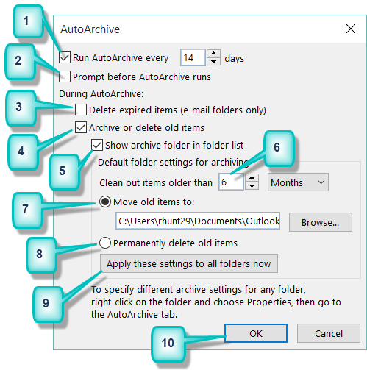

|  |  |
| --- | --- |
| **1** | ***Run AutoArchive every***: Checking this box turns on **AutoArchive**. You can then choose how often AutoArchive runs in days (from 1 – 60). |
| **2** | ***Prompt before AutoArchive runs***: Choose this option to display a reminder message before AutoArchive runs. When the message pops up at an inconvenient time, click **No** to cancel that AutoArchive session. |
| **3** | ***Delete expired items (email folders only)***: This option is not selected by default. If chosen, email messages are deleted when their aging period has expired and NOT archived. The default aging period for **Inbox** and **Draft** folder items is six months and three months for the **Sent Items** folder. These periods can be changed using the ***Clean out items older than*** option (#5). |
| **4** | ***Archive or delete old items***: Choose this option if Outlook is to archive items or delete them when they expire. Choose additional settings to apply to both archiving and deletion. |
| **5** | **Show archive folder in folder list**: Checking this box causes the **Archive Folder** to be listed with other folders in the **Navigation Pane**. In the main **Archive** folder, subfolders can be opened and archived items viewed. |
| **6** | ***Clean out items older than***: This sets the **aging** or **expiration** period in a certain number of days, weeks, or months for emails. Periods of one day up to 60 months can be configured. "**Clean**" means to archive or store items. It does not mean "deleted" unless that setting has been selected elsewhere. |
| **7** | ***Move old items to***: Select this option to have Archived emails stored in the default ***archive.pst*** file. This file location is displayed in the field.  Click the ***Browse*** button to set another location for the ***archive.pst*** file. Emails are moved to this location once they reach the set aging parameter.  **Default Destinations:**  **Microsoft Windows 8.1 and 10**: C:\Users\(your user name)\Documents\Outlook Files\archive.pst |
| **8** | ***Permanently delete old items***: This option immediately deletes the expired items instead of moving them to the default archive location. **Caution**: Only use this if no emails are to be archived. |
| **9** | ***Apply these settings to all folders now***: This button applies the **AutoArchive** settings to all folders. To specify different settings for individual folders, use the instructions shown below the button (see also the ***Changing AutoArchive Settings for Individual Folders*** section). Changes made to specific folders apply only to those folders and their sub-folders. |
| **10** | Click the ***OK*** button to save your changes and run **AutoArchive**. |

### Changing AutoArchive Settings for Individual Folders

**AutoArchive** settings can be set for individual folders, including ***Inbox***, ***Sent Items***, ***Deleted Items***, and **user created folders**. This allows the contents of individual folders:

* to not be archived or,
* be archived using the default settings or,
* be archived differently than default:
  + be archived when reaching a certain age.
  + be archived to different locations.
  + be permanently deleted.

**NOTE:** The ***Contacts*** folder is not archived.

To change an individual folder’s **AutoArchive** settings, do the following:

|  |  |
| --- | --- |
| 1. **Right** click on the folder whose archive settings are to be changed. 2. In the drop-down menu, click on ***Properties***. | C:\Users\rhunt29\AppData\Local\Temp\1\SNAGHTML1610684f.PNG |
| 1. This opens the **(*folder name*)Properties** dialog box. 2. Select the ***AutoArchive*** tab. 3. Select ***Archive this folder using these settings:*** 4. Set Archive settings for this folder.   For an explanation of the ***AutoArchive*** tab and changing the settings for the selected folder, see the next page. | C:\Users\rhunt29\AppData\Local\Temp\1\SNAGHTML16163607.PNG |

### Explanation of *(Folder Name) Properties* Dialog Box:

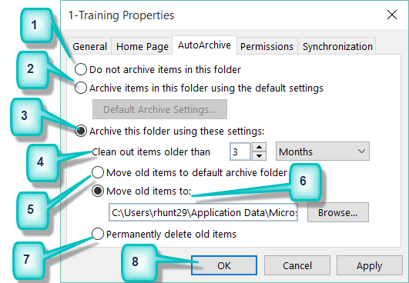

**NOTE:** Changes to the properties of a folder are also applied to its sub-folders.

|  |  |
| --- | --- |
| **1** | **Do not archive items in this folder** - Selecting this button turns off **AutoArchive** for this folder. |
| **2** | **Archive items in this folder using the default settings:** - This sets this folder to archive at default settings.  ***Default Archive Settings…* button** - Click thisbutton to access the ***AutoArchive*** dialog box and view or change the default settings. (See ***The AutoArchive dialog box explained****:* in the previous section.). |
| **3** | ***Archive this folder using these settings:*** Choose this option to set this folder to archive differently from the default settings. |
| **4** | **Clean out items older than** – Use this option to change how old (when they expire) items are when archived. Set the **Number** and then choose **Days**, **Weeks,** or **Months**. Periods of 1 day up to 60 months can be configured. "**Clean**" means to archive or store items. It does not mean "deleted" unless that setting has been selected elsewhere. |
| **5** | ***Move old items to default archive folder***: Select this option to move items to the default AutoArchive location. This location is found in the AutoArchive dialog box and can be changed. (See ***Find/Change AutoArchive Default Settings*** section). |
| **6** | ***Move old items to***: Select this option if the contents of this folder are to be archived at location different than the default location.  Use the ***Browse*** button to navigate to the archive location. |
| **7** | ***Permanently delete items***: This option immediately deletes the matured items in the folder instead of moving them to an archive folder.  **Caution**: Only use this option if folder contents are **not** to be archived. |
| **8** | Click the ***OK*** button to save your AutoArchive changes for the selected folder and its sub-folders. |