Pharos MobilePrint Information
Start by going to http://mobileprint.slcc.edu/. This page has the information to get it all started, too.

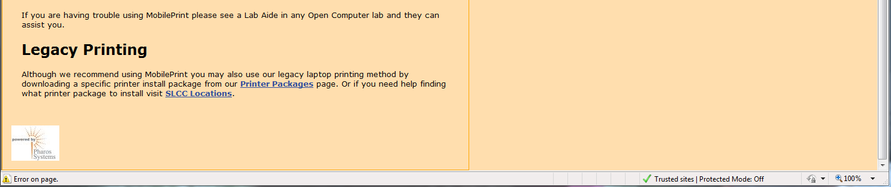
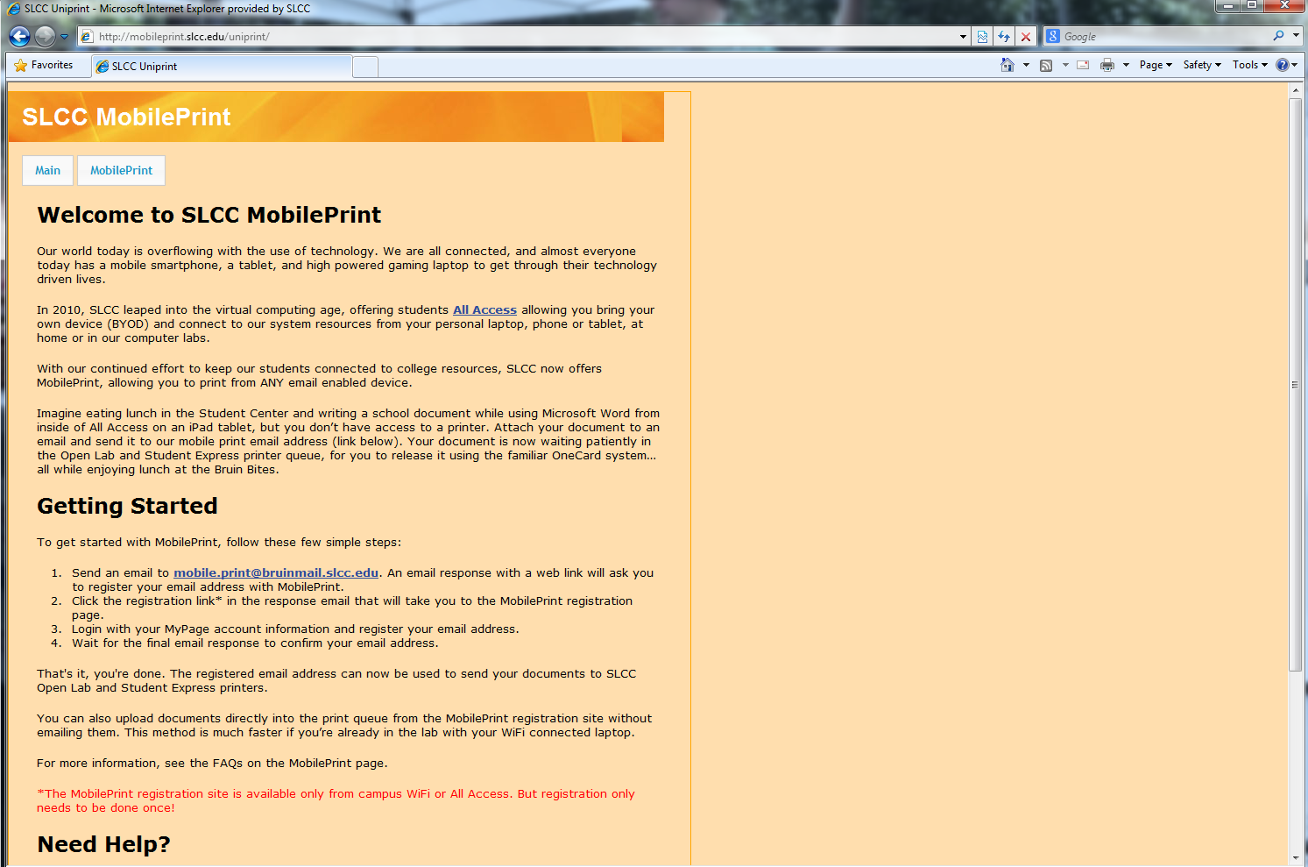
Mobile Print Button

Clicking on the MobilePrint button across the top will bring you to the login page. (https://mobileprint.slcc.edu:9001/webrelease)
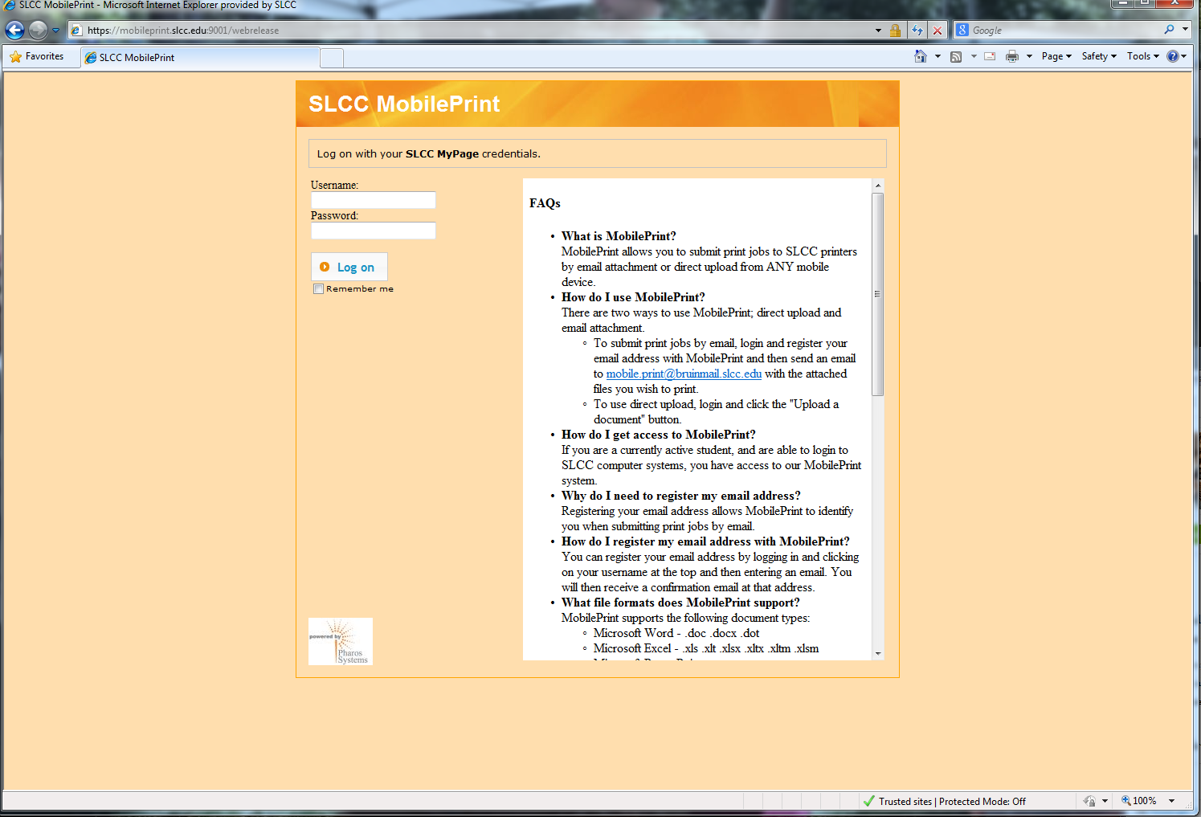
Which in turn will take you to this page…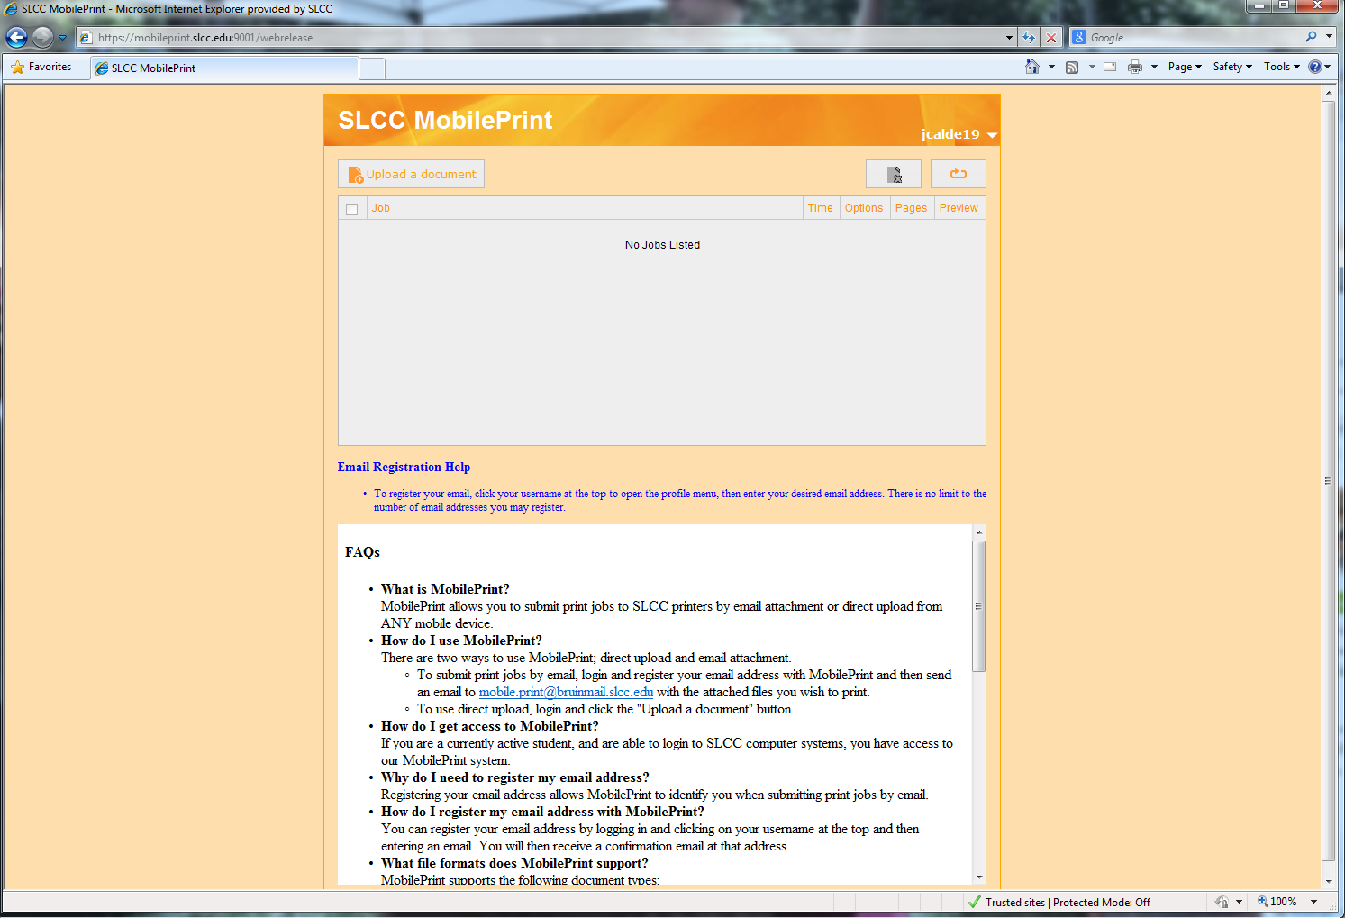
Upload
Username
From that page you click your username at the top right, and it will ask for your email address.
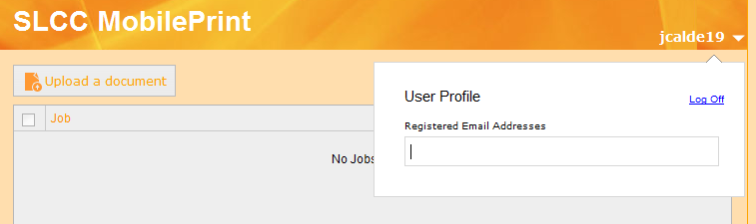
Enter your email address. You will be sent a confirmation email to that account. Open that email and click the confirmation link. You can enter in multiple email addresses.
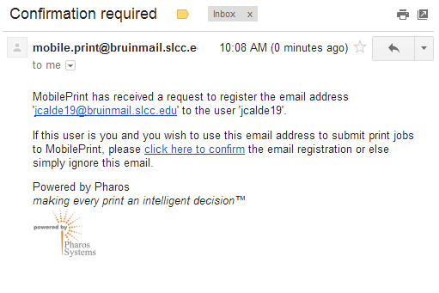
Confirm
The link will send you to this screen. Click the Confirm button. You will be redirected back to the Mobile Print page.
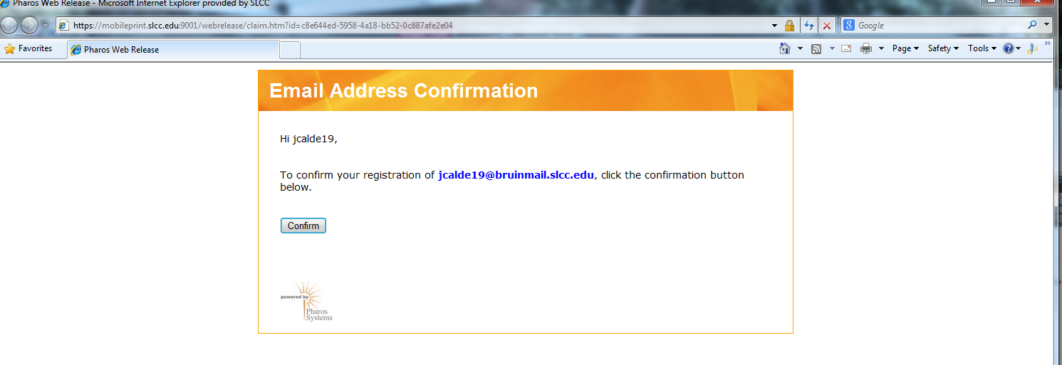
Confirm
You can either email the document to mobile.print@bruinmail.slcc.edu or you can upload the file from the All Access H: drive, computer or flash drive and send it to the queue. You can then go to the Pharos printer in one of these 7 places.

MobilePrint submitted jobs may ONLY be released at the following SLCC locations:

- Redwood Open Computer Lab - Library - Main Floor
- Redwood Student Express Lab - Student Center - Second Floor
- South Open Computer Lab - Second Floor - Room W285
- South Student Express Lab - First Floor - Room W137
- Miller Open Computer Lab - MFEC - Room 207
- Jordan Open Computer Lab - Health Science Center - Atrium
- Jordan Student Express Lab - High-Tech Center - Main Floor

